Air Transfer Grille (ATG)
Suitability
The Exitex range of Air Transfer Grilles are suitable for use in fire resisting timber door sets for 30 and 60 minute fire resistance.
General Guidance
Firstly, the installer must ensure that the doorset/ door blank has been tested with an aperture to accept an air transfer grille system for the required period of fire resistance. Failure to comply with the requirements and instructions detailed in the specification of the doorset/ blank may invalidate the fire resistance period of the fire resisting door assembly.
Position and location within the doorset (Fig A)
As the test includes both positive and negative pressure tests it is considered that the proposed grilles may be installed within doorsets adhering to the following parameters. The system shall be installed no closer than 150mm to the floor and no higher than 1850mm.
Installation Procedure (Fig B)
- Cut the aperture in the door [The system must be installed no closer than 150mm to the floor and no higher than 1850mm].
- Line the aperture with a 6mm hardwood liner as recommended by the door manufacturer.
- Apply a bead of Exitex Intumescent Acrylic Sealant across the full width of timber liner, to achieve a thickness of 0.5mm.
- Install the Exitex ATG into the aperture.
- Secure the system into place using steel pins or self-tapping screws as recommended by the door manufacturer, (steel pins / self-tapping screws not supplied).
- Fit the cover plates on both faces of the door and secure with screws provided.
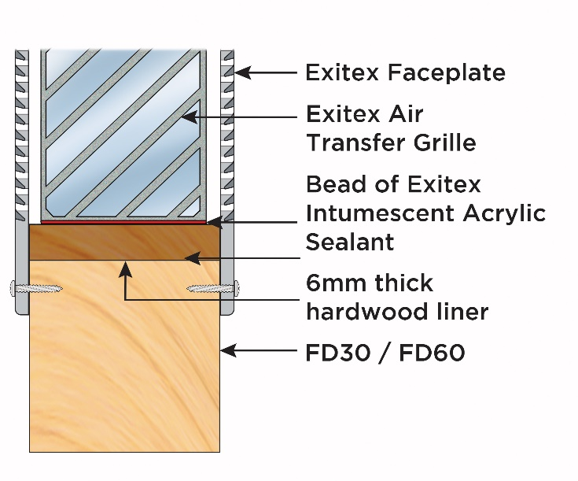
Fig A Fig B
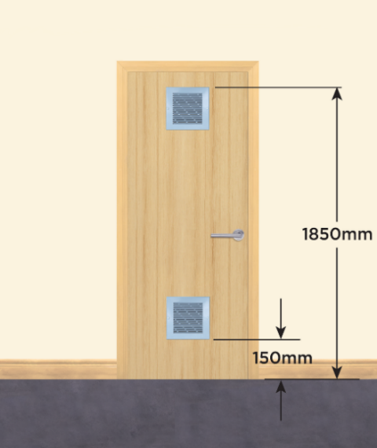
www.exitex.com

